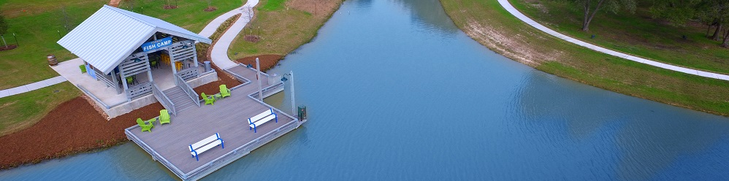

Alvin ISD Rezoning 2020
Alvin ISD approved boundary changes that affect students living in Pomona at the February 11, 2020 Board meeting. Incoming 6th graders will attend Rodeo Palms Junior High and incoming 9th graders will attend Manvel High School. All elementary students will attend Pomona Elementary.
There is an opportunity for currently enrolled students to remain at the campus that they currently attend through grade level transition from that campus. The following are the stipulations for zoning transfers:
  - TRANSPORTATION WILL NOT BE PROVIDED - If a student is on a transfer to remain at a campus after the rezoning process the District will not provide transportation.
  - DEADLINE - For consideration under this clause the transfer request must be completed and submitted by the published deadline. (March 6, 2020)
  - CURRENTLY ENROLLED - Transfers will be available for students currently enrolled on the affected campus. Students yet to enroll, including siblings, will enroll in the most recently zoned campus.
  - APPROVAL GUIDELINES - Student must be in good standing with discipline and attendance to be eligible for transfer.
    - Attendance - less than 5 absences, of any kind, in the 2019-2020 school year.
    - Tardies - less than 5 tardies in the 2019-2020 school year.
    - Discipline - less than 3 discipline referrals in the 2019-2020 school year
    - Discipline - no significant discipline consequence (OSS, or alternative placement during the 2019-2020 school year.
LIMITATIONS
  - Transfer is only for the campus where the student is currently enrolled. These transfers do not apply after campus grade transition.
  - Only students who are enrolled with a valid proof of residency as a bona-fide resident are eligible for consideration for a transfer due to zoning changes.
  - Transfer application will have to be submitted and approved annually to continue enrollment.
For more information, please visit Alvin ISD’s website at
www.alvinisd.net/Page/18750

